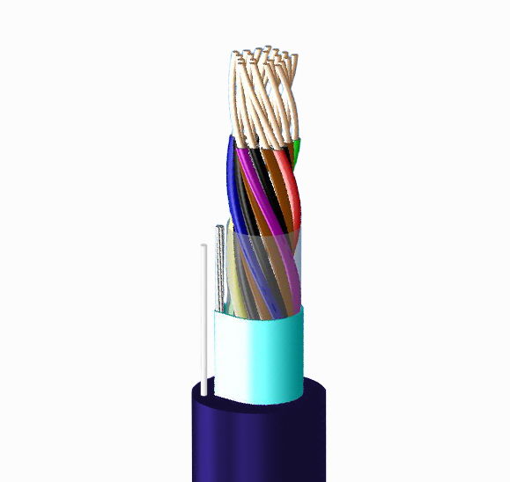
PE-PVC INDOOR CABLE

Applications：
This cable is PE insulated PVC jacketed unit type quad cable, used as telephone distribution circuits inside building.
The wires of the cable are identified by the color code of insulation.

Conductor |  | No. of pair | PVC Insulation | PVC  Overall | Diameter Overall | Standard
AWG | Diameter (mm/inch) | P | Thickness (mm/inch) | Thickness (mm/inch) | max. (mm/inch) | Length (m/ft)
26 | 0.40/0.016 | 6 | 0.15/0.006 | 1.3/0.051 | 6/0.236 | 500/152.5
26 | 0.40/0.016 | 10 | 0.15/0.006 | 1.3/0.051 | 7/0.275 | 500/152.5
26 | 0.40/0.016 | 26 | 0.15/0.006 | 1.3/0.051 | 11/0.433 | 500/152.5
26 | 0.40/0.016 | 30 | 0.15/0.006 | 1.3/0.051 | 11/0.433 | 500/152.5
26 | 0.40/0.016 | 50 | 0.15/0.006 | 1.4/0.055 | 13/0.512 | 500/152.5
26 | 0.40/0.016 | 100 | 0.15/0.006 | 1.6/0.062 | 17/0.670 | 500/152.5
26 | 0.40/0.016 | 200 | 0.15/0.006 | 1.9/0.074 | 24/0.945 | 500/152.5
24 | 0.50/0.02 | 6 | 0.17/0.007 | 1.3/0.052 | 7/0.275 | 500/152.5
24 | 0.50/0.02 | 10 | 0.17/0.007 | 1.3/0.052 | 8/0.315 | 500/152.5
24 | 0.50/0.02 | 26 | 0.17/0.007 | 1.3/0.052 | 12/0.472 | 500/152.5
24 | 0.50/0.02 | 30 | 0.17/0.007 | 1.3/0.052 | 12/0.472 | 500/152.5
24 | 0.50/0.02 | 50 | 0.17/0.007 | 1.4/0.055 | 15/0.590 | 500/152.5
24 | 0.50/0.02 | 100 | 0.17/0.007 | 1.6/0.063 | 20/0.787 | 500/152.5
24 | 0.50/0.02 | 200 | 0.17/0.007 | 2.0/0.078 | 27/1.063 | 500/152.5

Characteristics：
Items | Specification
Conductor Resistance (20℃) | 0.40mm(TC) 147.5 Ω/km max.
Conductor Resistance (20℃) | 0.50mm(TC) 93.5 Ω/km max.
Insulation Resistance (20℃,DC 100~500V/1min) | 5000 MΩ-km min.
Dielectric Strength | D.C. 500 V/1min or A.C. 350 V/1min
Capacitance (1KHz) | 100P↑ 55 nF/km Max.

